**Lab 3 & 4: Introduction to Raspberry Pi and its components**

In this project you will connect up a Raspberry Pi computer and find out what it can do.

The Raspberry Pi is a small computer that can do lots of things. You plug it into a monitor and attach a keyboard and mouse.



**What you will need**

**Hardware**

* A Raspberry Pi computer with an SD card
* A monitor with a cable (and, if needed, an HDMI adaptor)
* A USB keyboard and mouse
* A power supply
* Headphones or speakers (optional)
* An ethernet cable (optional)

**Software**

* Raspbian, installed via NOOBS

**Meet the Raspberry Pi**

Let’s take a look at the Raspberry Pi. You should have a Raspberry Pi computer in front of you for this. It shouldn’t be connected to anything yet.

* Look at your Raspberry Pi. Can you find all the things labelled on the diagram?

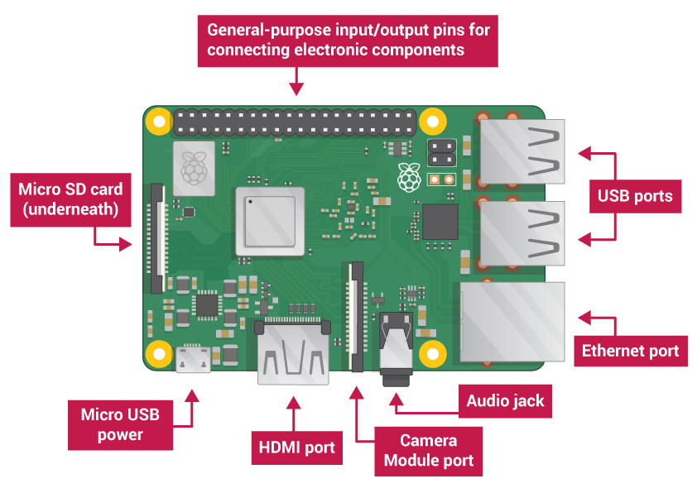

* USB ports — these are used to connect a mouse and keyboard. You can also connect other components, such as a USB drive.
* SD card slot — you can slot the SD card in here. This is where the operating system software and your files are stored.
* Ethernet port — this is used to connect the Raspberry Pi to a network with a cable. The Raspberry Pi can also connect to a network via wireless LAN.
* Audio jack — you can connect headphones or speakers here.
* HDMI port — this is where you connect the monitor (or projector) that you are using to display the output from the Raspberry Pi. If your monitor has speakers, you can also use them to hear sound.
* Micro USB power connector — this is where you connect a power supply. You should always do this last, after you have connected all your other components.
* GPIO ports — these allow you to connect electronic components such as LEDs and buttons to the Raspberry Pi.

**Connect your Raspberry Pi**

Let’s connect up your Raspberry Pi and get it running.

* Check whether your Raspberry Pi already has an SD card in the slot at the underside, and if not, insert an SD card with Raspbian installed (via NOOBS).

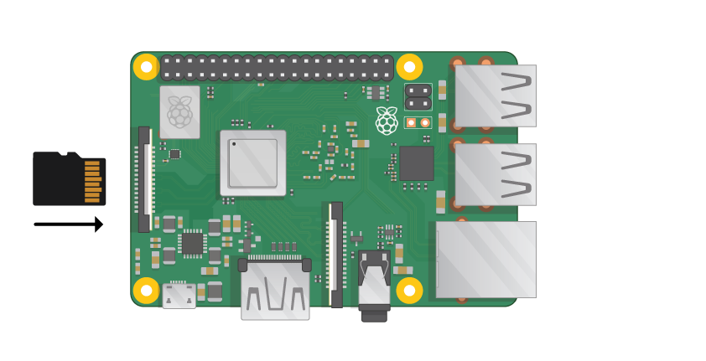

Note: Lots of micro SD cards will come inside a larger adapter — you can slide the card out using the lip at the bottom.

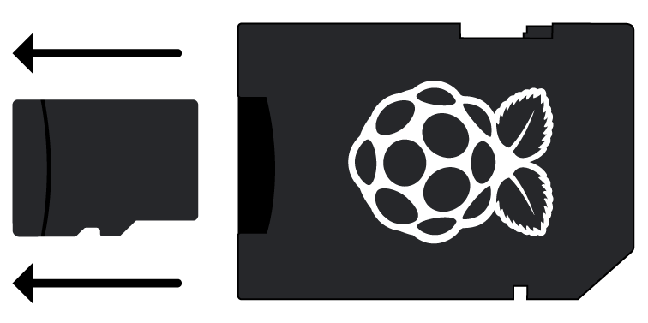

* Find the USB connector for your mouse, and connect the mouse to one of the USB port on the Raspberry Pi (it doesn’t matter which one).

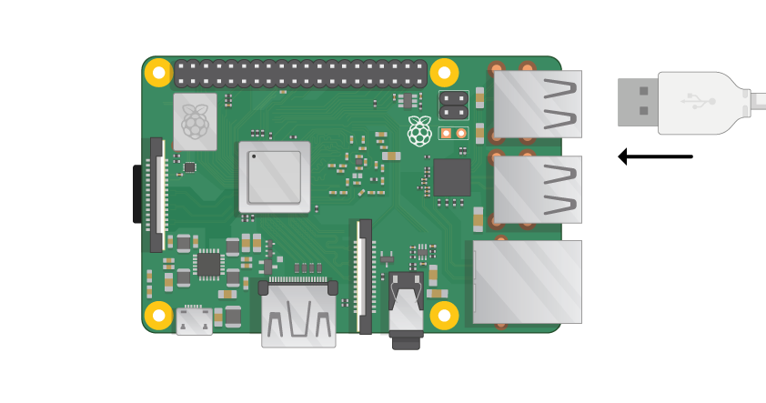

* Connect the keyboard in the same way.

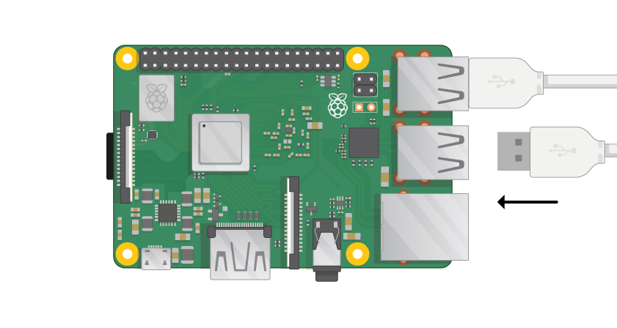

* Look at the HDMI port on the Raspberry Pi — notice that it has a large flat side on top.

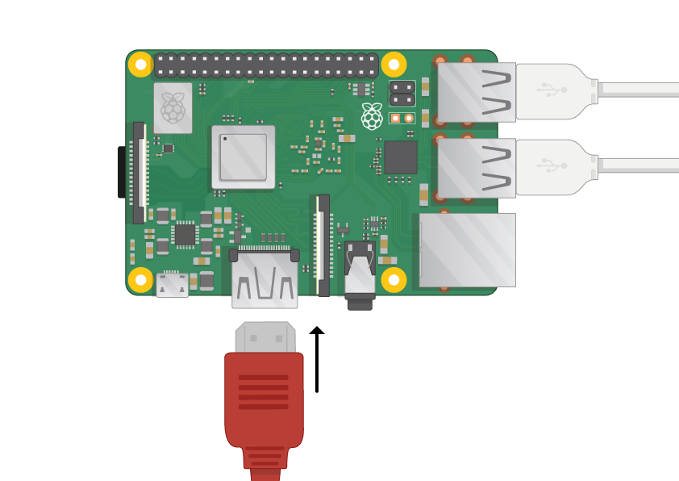

Make sure your monitor is plugged into a wall socket and turned on.

* Connect the monitor cable to the Pi’s HDMI port — use an adapter if necessary.

Nothing will display yet.

* If you want to connect the Pi to the internet via Ethernet, use an Ethernet cable to connect the Ethernet port on the Raspberry Pi to an Ethernet socket on the wall or on your internet router. You don’t need to do this if you’ll be using Wi-Fi or if you don’t want to connect to the internet.

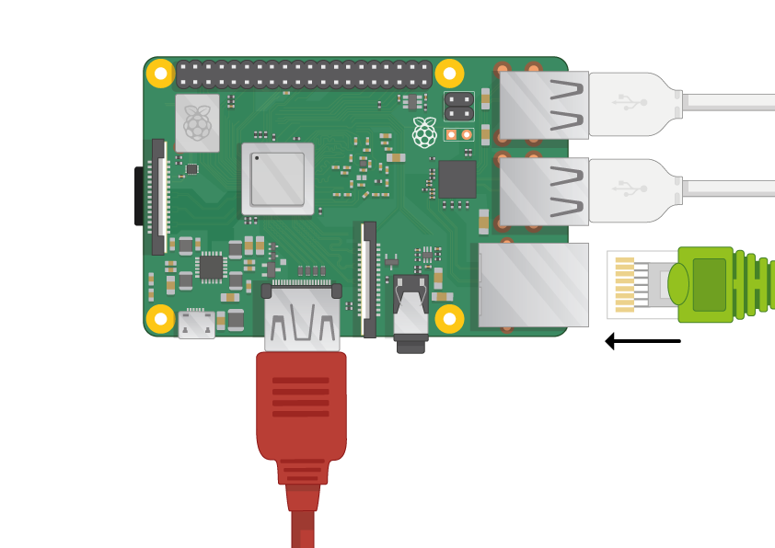

* Sound will come from your screen if it has speakers or you can connect headphones or speakers to the audio jack if you have them.

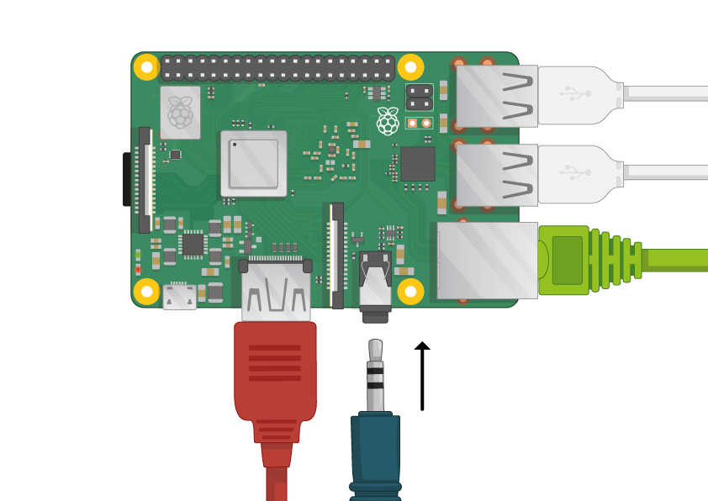

* Notice that the micro USB power port has a longer flat side on top.

Plug the power supply into a socket and connect it to the micro USB power port.

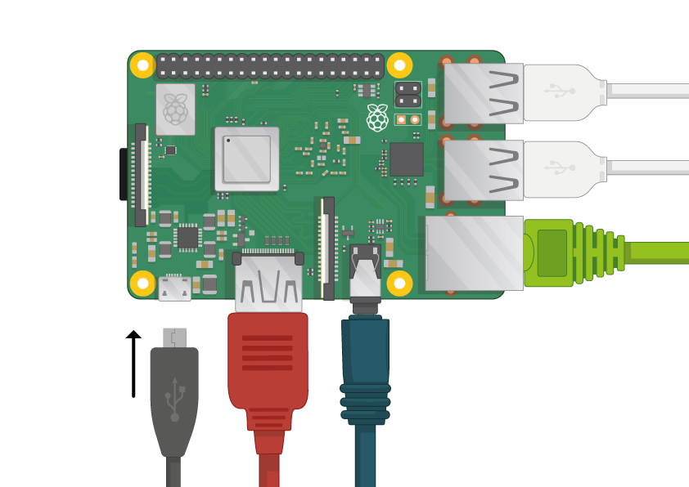

You should see a red light on the Raspberry Pi and raspberries on the monitor.

The Pi will boot up into a graphical desktop.

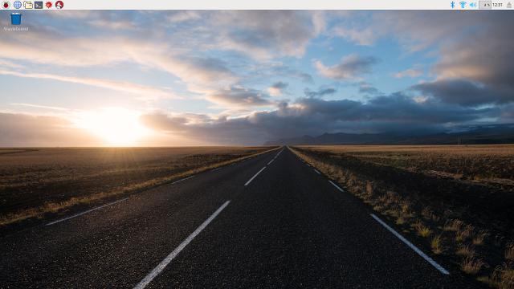

Finish the setup

When you start your Raspberry Pi for the first time, the Welcome to Raspberry Pi application will pop up and guide you through the initial setup.



* Click Next to start the setup.
* Set your Country, Language, and Time zone, then click next again.

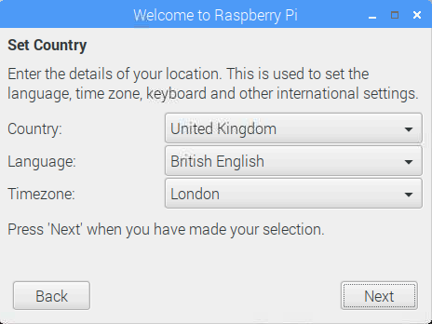

* Enter a new password for your Raspberry Pi and click Next.

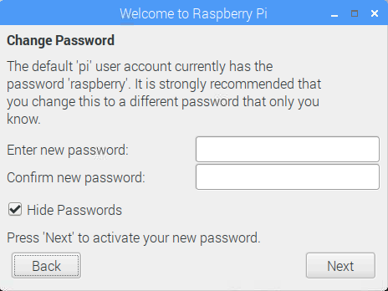

* Connect to your Wi-Fi network by selecting its name, entering the password, and clicking next.

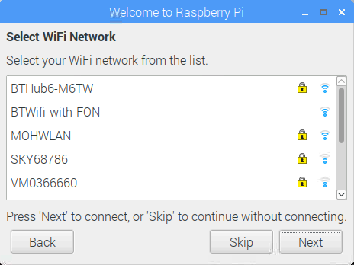

Note: if your Raspberry Pi model doesn’t have wireless connectivity, you won’t see this screen.

* Click Next let the wizard check for updates to Raspbian and install them (this might take a little while).

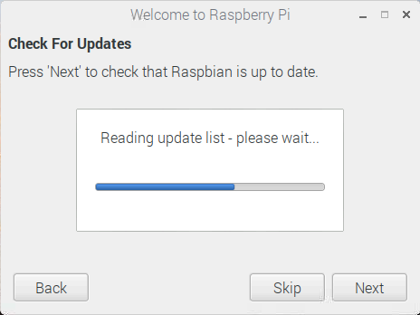

* Click Done or Reboot to finish the setup.

Note: you will only need to reboot if that’s necessary to complete an update.

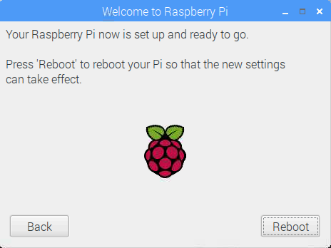

**A tour of the Raspberry Pi**

Now it’s time to take a tour of the Raspberry Pi.

* See that Raspberry up in the top left-hand corner? That’s where you access the menu: click on it, and you will find lots of applications.
* Click Accessories and choose Text Editor.

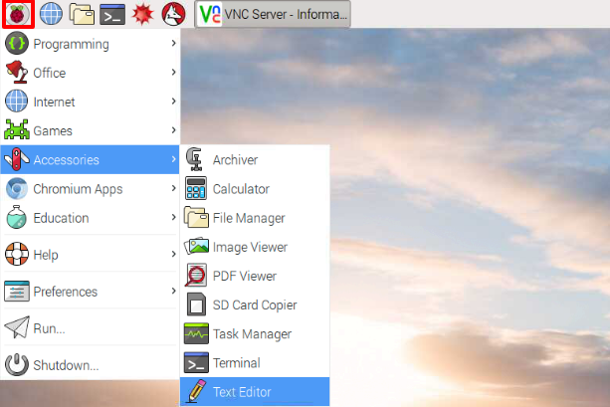

* Type I just built a Raspberry Pi in the window that appears.

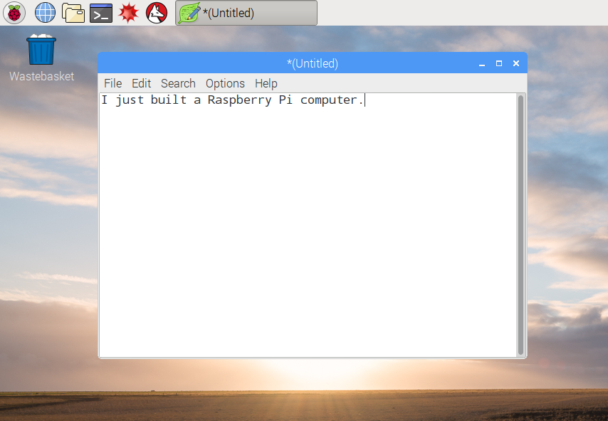

* Click on File, then choose Save, and then click on Desktop and save the file as rp.txt.

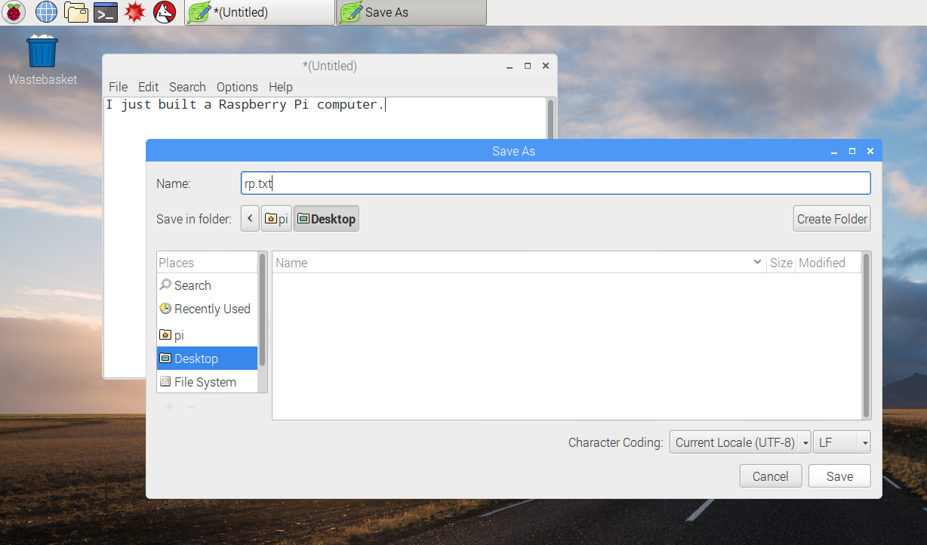

* You should see an icon named rp.txt appear on the desktop.

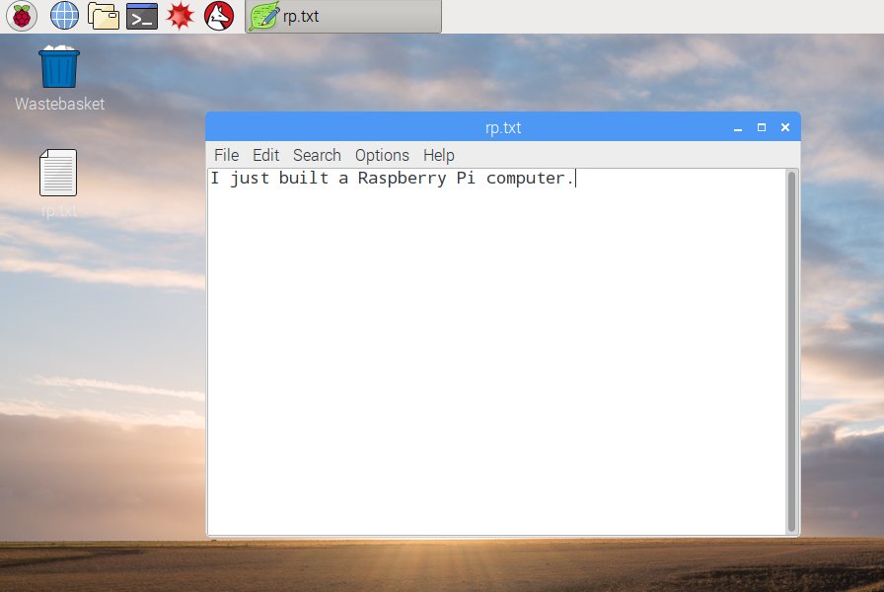

Your file has been saved to the Raspberry Pi’s SD card.

* Close the text editor by clicking the X in the top right-hand corner of the window.
* Return to the Raspberry menu, choose Shutdown, and then choose Reboot.
* When the Pi has rebooted, your file should still be there.
* The Raspberry Pi runs a version of an operating system called Linux (Windows and macOS are other operating systems). It allows you to make things happen by typing commands instead of clicking on menu options. Click on the Terminal at the top of the screen:

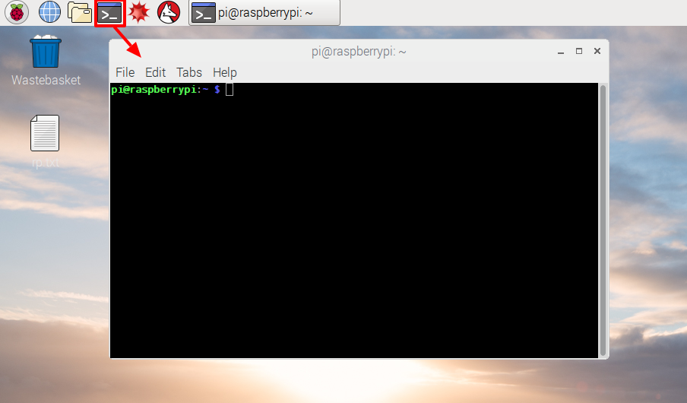

* In the window that appears, type:

ls

and then press Enter on the keyboard.

This will list the files in your home directory.

* Now type this command to change directory to the Desktop:

cd Desktop

You have to press the Enter key after every command.

Type:

ls

Can you see the file you created?

* Close the terminal window by clicking on the X.
* Now drag rp.txt to the Wastebasket on the desktop so the Pi will be ready for the next person.

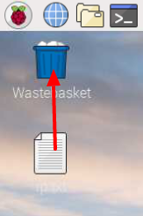

# **GPIO**

A powerful feature of the Raspberry Pi is the row of GPIO (general-purpose input/output) pins along the top edge of the board. A 40-pin GPIO header is found on all current Raspberry Pi boards (unpopulated on Pi Zero and Pi Zero W). Prior to the Pi 1 Model B+ (2014), boards comprised a shorter 26-pin header.

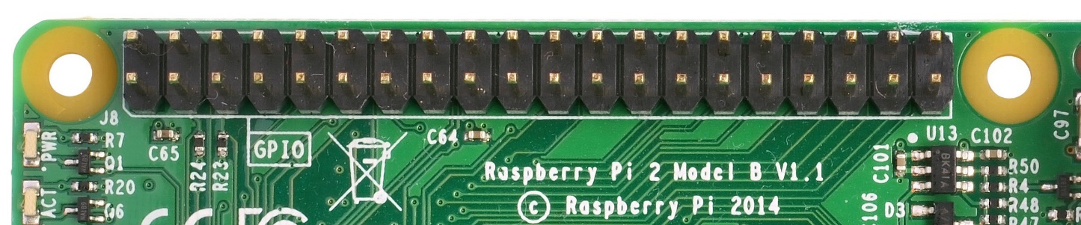

Any of the GPIO pins can be designated (in software) as an input or output pin and used for a wide range of purposes.

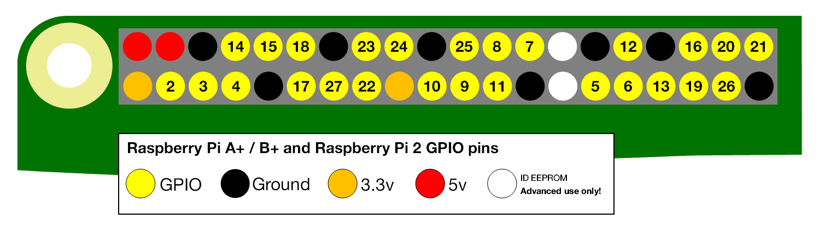

**Note: the numbering of the GPIO pins is not in numerical order; GPIO pins 0 and 1 are present on the board (physical pins 27 and 28) but are reserved for advanced use (see below).**

## Voltages

Two 5V pins and two 3V3 pins are present on the board, as well as a number of ground pins (0V), which are unconfigurable. The remaining pins are all general purpose 3V3 pins, meaning outputs are set to 3V3 and inputs are 3V3-tolerant.

## Outputs

A GPIO pin designated as an output pin can be set to high (3V3) or low (0V).

## Inputs

A GPIO pin designated as an input pin can be read as high (3V3) or low (0V). This is made easier with the use of internal pull-up or pull-down resistors. Pins GPIO2 and GPIO3 have fixed pull-up resistors, but for other pins this can be configured in software.

## More

As well as simple input and output devices, the GPIO pins can be used with a variety of alternative functions, some are available on all pins, others on specific pins.

* PWM (pulse-width modulation)
  + Software PWM available on all pins
  + Hardware PWM available on GPIO12, GPIO13, GPIO18, GPIO19
* SPI
  + SPI0: MOSI (GPIO10); MISO (GPIO9); SCLK (GPIO11); CE0 (GPIO8), CE1 (GPIO7)
  + SPI1: MOSI (GPIO20); MISO (GPIO19); SCLK (GPIO21); CE0 (GPIO18); CE1 (GPIO17); CE2 (GPIO16)
* I2C
  + Data: (GPIO2); Clock (GPIO3)
  + EEPROM Data: (GPIO0); EEPROM Clock (GPIO1)
* Serial
  + TX (GPIO14); RX (GPIO15)

## GPIO pinout

It's important to be aware of which pin is which. Some people use pin labels (like the [RasPiO Ports plus](http://rasp.io/portsplus/) PCB, or the printable [Raspberry Leaf](https://github.com/splitbrain/rpibplusleaf)).

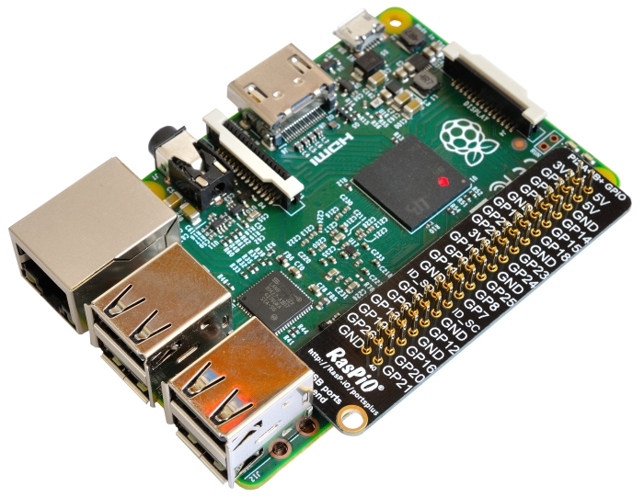

A handy reference can be accessed on the Raspberry Pi by opening a terminal window and running the command pinout. This tool is provided by the [GPIO Zero](https://gpiozero.readthedocs.io/) Python library, which it is installed by default on the Raspbian desktop image, but not on Raspbian Lite.

